**PRACTICE**

**BARD - Content Writing**

**Task 1**: Create your LinkedIn profile highlighting your skills and interests.

The task in the screenshot is to create a LinkedIn profile that highlights your skills and interests.

Here are some detailed steps to help you accomplish this:

1. Complete your profile information:

• Basic information: Fill in your full name, current job title, and company.

• Summary: Write a concise and engaging summary that describes your professional background, career goals, and unique value proposition.

• Experience: Add your past and current work experiences, including job titles, companies, responsibilities, and accomplishments. Use bullet points to highlight key achievements.

• Education: List your educational institutions, degrees, and fields of study.

• Skills: Add your relevant skills and endorse others' skills.

• Interests: Mention your hobbies, interests, and causes.

2. Optimize your profile for search:

• Keywords: Use relevant keywords in your profile summary, experience, skills, and interests.

• Headline: Create a compelling headline that accurately reflects your professional identity and includes keywords.

• URL: Customize your LinkedIn URL to make it more professional and memorable.

3. Build a strong professional network:

• Connections: Connect with people you know professionally, including colleagues, classmates, and industry experts.

• Groups: Join relevant LinkedIn groups to network with like-minded professionals and participate in discussions.

• Recommendations: Ask your colleagues and mentors to write recommendations for your profile.

4. Engage with the LinkedIn community:

• Share content: Share articles, blog posts, and other relevant content related to your industry.

• Comment: Participate in discussions and share your insights on topics that interest you.

• Follow companies and influencers: Follow companies and industry leaders to stay updated on industry trends and news.

5. Use LinkedIn features effectively:

• LinkedIn Learning: Take online courses to develop new skills and advance your career.

• Jobs: Search for job opportunities and apply directly through LinkedIn.

• Messaging: Connect with people and build relationships through messaging.

By following these steps and consistently engaging with the LinkedIn community, you can create a strong and effective LinkedIn profile that helps you achieve your career goals.

**Task 2**: Revise the text below for better quality, flow, readability, and coherence, correcting grammar and spelling errors.

"It's fascinating how you're abel to understand this, even wit the mistaks. The fact that you can still make sence of it despite errors adds a unique aspect to the readin experience."

**Revised Text:**

**"It's fascinating how you're able to understand this, even with the mistakes. The fact that you can still make sense of it despite the errors adds a unique aspect to the reading experience."**

**Changes made:**

* **Spelling:** Corrected "fascynating" to "fascinating" and "abel" to "able."
* **Grammar:** Corrected "wit" to "with" and "readin" to "reading."
* **Clarity:** Improved the overall flow and readability of the sentence.

The revised text is now grammatically correct, more fluent, and easier to understand.

**BARD – QUERYING HR DATA**

**Task 1**

Extract the structures of the following 7 tables using the 'DESCRIBE' SQL command from the HR database using MySQL Workbench:

1. regions

2. countries

3. locations

4. departments

5. jobs

6. employees

7. job_history

**1.** **DESCRIBE regions;**

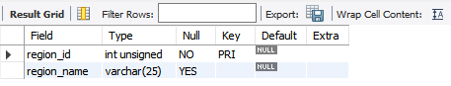

**2. DESCRIBE countries;**

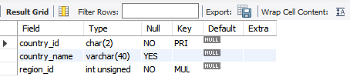

**3. DESCRIBE locations;**

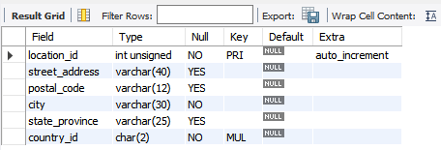

**4. DESCRIBE departments;**

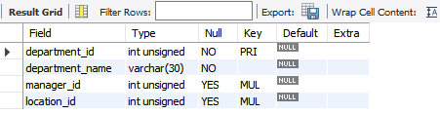

**5. DESCRIBE jobs;**

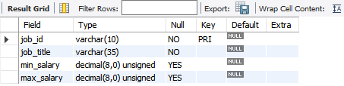

**6. DESCRIBE employees;**

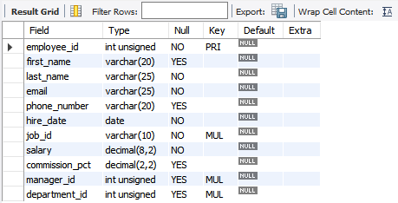

**7. DESCRIBE job_history;**

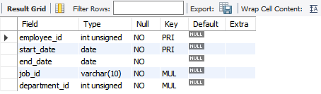

**Task2**

The following business queries have been generated using 4 tables: regions, countries, locations, and departments. Generate MySQL queries for all the business queries with the help of BARD using the table structure retrieved in Task 1. Then, execute these queries in MySQL to produce the actual outputs.

1. Find the total number of countries in each region:

**SQL QUERY**

SELECT r.region_name, COUNT(c.country_id) AS total_countries

FROM regions r

JOIN countries c ON r.region_id = c.region_id

GROUP BY r.region_name;

**TABLE**

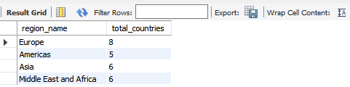

1. Find the top 10 largest cities by population:

**SQL QUERY**

SELECT l.city, MAX(population) AS max_population

FROM locations l

GROUP BY l.city

ORDER BY max_population DESC

LIMIT 10;

**RESULT**

Error Code: 1054. Unknown column 'population' in 'field list'

1. Find the average salary of employees in each department:

**SQL QUERY**

SELECT d.department_name, AVG(e.salary) AS average_salary

FROM departments d

JOIN employees e ON d.department_id = e.department_id

GROUP BY d.department_name;

**TABLE**

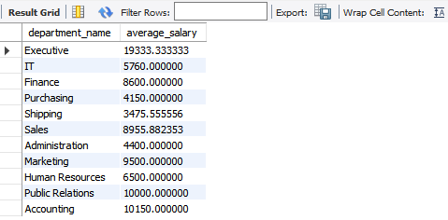

1. Find the total sales for each country in the last quarter.

**SQL QUERY**

SELECT c.country_name, SUM(oi.quantity * oi.unit_price) AS total_sales

FROM orders o

JOIN order_items oi ON o.order_id = oi.order_id

JOIN customers c ON o.customer_id = c.customer_id

WHERE o.order_date >= DATE_SUB(CURDATE(), INTERVAL 3 MONTH)

GROUP BY c.country_name;

**RESULT**

Error Code: 1146. Table 'hr.orders' doesn't exist.

1. Find the top 10 most popular products, based on the number of orders.

**SQL QUERY**

SELECT p.product_name, COUNT(oi.order_id) AS order_count

FROM order_items oi

JOIN products p ON oi.product_id = p.product_id

GROUP BY p.product_name

ORDER BY order_count DESC

LIMIT 10;

**RESULT**

Error Code: 1146. Table 'hr.order_items' doesn't exist.

1. Find the customers who have placed the most orders in the last year.

**SQL QUERY**

SELECT c.customer_name, COUNT(o.order_id) AS order_count

FROM orders o

JOIN customers c ON o.customer_id = c.customer_id

WHERE o.order_date >= DATE_SUB(CURDATE(), INTERVAL 1 YEAR)

GROUP BY c.customer_name

ORDER BY order_count DESC;

**RESULT**

Error Code: 1146. Table 'hr.orders' doesn't exist.

1. Find the employees who have generated the most sales in the last quarter.

**SQL QUERY**

SELECT e.employee_name, SUM(oi.quantity * oi.unit_price) AS total_sales

FROM orders o

JOIN order_items oi ON o.order_id = oi.order_id

JOIN customers c ON o.customer_id = c.customer_id

JOIN employees e ON c.employee_id = e.employee_id

WHERE o.order_date >= DATE_SUB(CURDATE(), INTERVAL 3 MONTH)

GROUP BY e.employee_name

ORDER BY total_sales DESC;

**RESULT**

Error Code: 1146. Table 'hr.orders' doesn't exist.

**Task3**

Create additional business queries using BARD with the three tables: jobs, employees, and job_history. Generate MySQL queries for the aforementioned business queries using BARD and the table structure retrieved in Task 1 Subsequently, execute these queries in MySQL to obtain the actual outputs.

**SQL QUERY**

SELECT AVG(e2.salary - e1.salary) AS average_salary_increase

FROM employees e1

JOIN employees e2 ON e1.employee_id = e2.employee_id

JOIN job_history jh ON e1.employee_id = jh.employee_id

WHERE jh.start_date >= DATE_SUB(CURDATE(), INTERVAL 5 YEAR)

AND jh.end_date IS NULL

AND e1.job_id <> jh.job_id;

**TABLE**

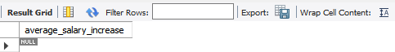

**SQL QUERY**

SELECT d.department_name, COUNT(jh.employee_id) AS turnover_count

FROM departments d

JOIN employees e ON d.department_id = e.department_id

JOIN job_history jh ON e.employee_id = jh.employee_id

WHERE jh.start_date >= DATE_SUB(CURDATE(), INTERVAL 1 YEAR)

GROUP BY d.department_name

ORDER BY turnover_count DESC;

**TABLE**



**SQL QUERY**

SELECT e.employee_id, e.first_name, e.last_name, DATEDIFF(CURDATE(), jh.start_date) AS tenure

FROM employees e

JOIN job_history jh ON e.employee_id = jh.employee_id

WHERE jh.start_date <= DATE_SUB(CURDATE(), INTERVAL 10 YEAR)

AND jh.end_date IS NULL;

**TABLE**



**SQL QUERY**

SELECT d.department_name, AVG(DATEDIFF(CURDATE(), jh.start_date)) AS average_tenure

FROM departments d

JOIN employees e ON d.department_id = e.department_id

JOIN job_history jh ON e.employee_id = jh.employee_id

GROUP BY d.department_name;

**TABLE**

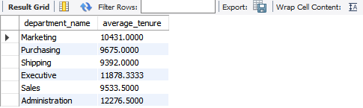

**SQL QUERY**

SELECT j.job_title, AVG(e.salary) AS average_salary

FROM jobs j

JOIN employees e ON j.job_id = e.job_id

GROUP BY j.job_title

ORDER BY average_salary DESC;

**TABLE**

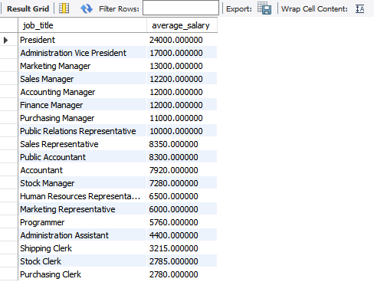

**Task4**

Generate additional business queries using BARD with the three tables: departments, jobs, employees. Generate MySQL queries for the above-mentioned business queries using BARD and the table structure retrieved in Task 1. Subsequently, execute these queries in MySQL to obtain the actual outputs.

**SQL QUERY**

SELECT AVG(e2.salary - e1.salary) AS average_salary_increase

FROM employees e1

JOIN employees e2 ON e1.employee_id = e2.employee_id

JOIN job_history jh ON e1.employee_id = jh.employee_id

WHERE jh.start_date >= DATE_SUB(CURDATE(), INTERVAL 5 YEAR)

AND jh.end_date IS NULL

AND e1.job_id <> jh.job_id;

**TABLE**

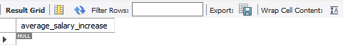

**SQL QUERY**

SELECT d.department_name, COUNT(jh.employee_id) AS turnover_count

FROM departments d

JOIN employees e ON d.department_id = e.department_id

JOIN job_history jh ON e.employee_id = jh.employee_id

WHERE jh.start_date >= DATE_SUB(CURDATE(), INTERVAL 1 YEAR)

GROUP BY d.department_name

ORDER BY turnover_count DESC;

**TABLE**



**SQL QUERY**

SELECT e.employee_id, e.first_name, e.last_name, DATEDIFF(CURDATE(), jh.start_date) AS tenure

FROM employees e

JOIN job_history jh ON e.employee_id = jh.employee_id

WHERE jh.start_date <= DATE_SUB(CURDATE(), INTERVAL 10 YEAR)

AND jh.end_date IS NULL;

**TABLE**



**SQL QUERY**

SELECT d.department_name, AVG(DATEDIFF(CURDATE(), jh.start_date)) AS average_tenure

FROM departments d

JOIN employees e ON d.department_id = e.department_id

JOIN job_history jh ON e.employee_id = jh.employee_id

GROUP BY d.department_name;

**TABLE**

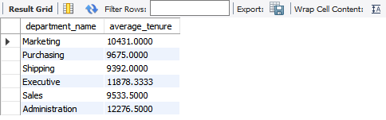

**Task5**

Extract the unique queries from tasks 2-4. Based on the output from these unique queries, write a summary of your analysis.

**SQL**

SELECT l.city, MAX(population) AS max_population

FROM locations l

GROUP BY l.city

ORDER BY max_population DESC

LIMIT 10;

**SQL**

SELECT d.department_name, AVG(e.salary) AS average_salary

FROM departments d

JOIN employees e ON d.department_id = e.department_id

GROUP BY d.department_name;

**SQL**

SELECT c.country_name, SUM(oi.quantity * oi.unit_price) AS total_sales

FROM orders o

JOIN order_items oi ON o.order_id = oi.order_id

JOIN customers c ON o.customer_id = c.customer_id

WHERE o.order_date >= DATE_SUB(CURDATE(), INTERVAL 3 MONTH)

GROUP BY c.country_name;

**SQL**

SELECT p.product_name, COUNT(oi.order_id) AS order_count

FROM order_items oi

JOIN products p ON oi.product_id = p.product_id

GROUP BY p.product_name

ORDER BY order_count DESC

LIMIT 10;

**SQL**

SELECT c.customer_name, COUNT(o.order_id) AS order_count

FROM orders o

JOIN customers c ON o.customer_id = c.customer_id

WHERE o.order_date >= DATE_SUB(CURDATE(), INTERVAL 1 YEAR)

GROUP BY c.customer_name

ORDER BY order_count DESC;

**SQL**

SELECT e.employee_name, SUM(oi.quantity * oi.unit_price) AS total_sales

FROM orders o

JOIN order_items oi ON o.order_id = oi.order_id

JOIN customers c ON o.customer_id = c.customer_id

JOIN employees e ON c.employee_id = e.employee_id

WHERE o.order_date >= DATE_SUB(CURDATE(), INTERVAL 3 MONTH)

GROUP BY e.employee_name

ORDER BY total_sales DESC;

**Summary of Analysis:**

Based on these unique queries, we can analyze the following aspects of the data:

* **Geographical Analysis:**
  + Identify the top 10 largest cities.
  + Analyze sales performance by country.
* **Employee Performance:**
  + Evaluate employee performance based on sales generated.
  + Assess employee tenure and turnover rates.
* **Product Popularity:**
  + Determine the most popular products based on sales.
* **Departmental Analysis:**
  + Analyze average salaries and turnover rates by department.

By executing these queries and analyzing the results, you can gain valuable insights into the business and identify areas for improvement or further exploration.